Master Functional Document

Application | NGERP - Centra
Service Bundle | Master Management
Service Request | Unit Of Measure

Description :

The Unit Measure of a product is defined in the Unit Of Measure Master. It helps to convert the quantity of a product from one to another. Example: Tin to carton.

Workflow Process :

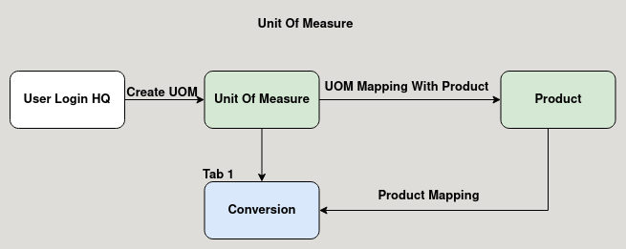

Business Rules :

- Unit of measure master is used to determine the quantity of a product.
- User can create unit of measure in HQ only.
- Once the unit of measure is created it is mapped with the product.
- The conversion tab is used to add the product to wich it is converted.
- When using the mapped product in transactions it is automatically converted to the conversion rate mapped in the unit of measure conversin tab.

